**BIG IDEAS:**

* Groundwater is between the grains of sand and gravel.
* Groundwater moves through spaces between sand and gravel particles due to gravity.
* Groundwater is connected to surface water.
* Groundwater is a part of the water cycle.
* We use groundwater!

**TIME:**

Model Set Up: 5 minutes

Working with the Model: 45 minutes

**LESSON:**

[*Build Your Own Groundwater*](https://arizona.app.box.com/file/783550265294?s=vm7yg8rw76pzgg5uicpxmqp7dcb2tfx2) *Model* – PowerPoint Presentation

**ADVANCE PREPARATION:**

* **Have your students gather the necessary materials to create their groundwater model.**

Your students will need a transparent plastic or glass container (like a food storage container), a pump from a soap/lotion bottle, gravel, and water. A dry erase marker and a rag for cleanup are optional but encouraged. *Hint: Gravel is a better medium for this experiment because sand/soil often gets caught within the pump.*

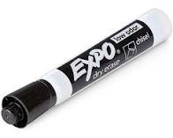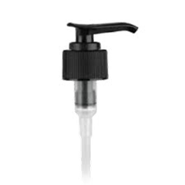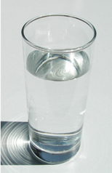 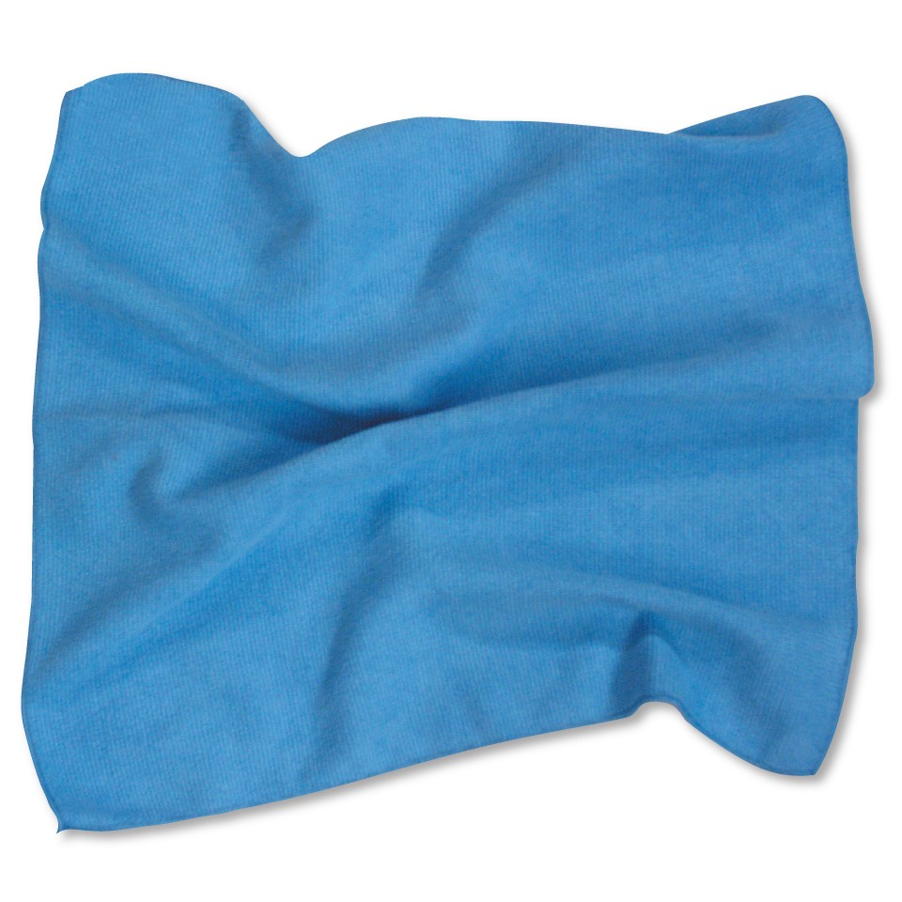

**MODEL CREATION**

* Have students watch the video. Joji will demonstrate how to set up their model in this YouTube video: [Build Your Own Aquifer – Part 1](https://www.youtube.com/watch?v=Q7YPH268X9g&list=PLl5fwrPBLdwpiYhhUWR4zJqot5SM_ksxD&index=13)
* ***OPTIONAL.*** In part 2, Joji instructs them on how to create a mountain and shows how they will be working with their model. [Build Your Own Aquifer – Part 2](https://www.youtube.com/watch?v=raBwN7k6vdw)

**WORKING WITH THE MODEL**

Use the link to [***Build Your Own Groundwater Model***](https://arizona.app.box.com/file/783550265294?s=vm7yg8rw76pzgg5uicpxmqp7dcb2tfx2) PowerPoint lesson to deliver the lesson. You may want to practice this lesson a few times in advance as you will be switching back and forth from the web cam to the presentation.