Name: _______________________ Date: ___________________
Organism interviewed: ____________________________
Interviewing an Organism Activity
Nature can be fascinating. A fun way to learn even more about a creature in its natural environment is to ask it questions. While the creatures can’t talk to us like humans, just thinking about what they might say or do gives us lots of additional information.
We’ll use four main categories of questions:
1) Descriptive questions: What does it look like? What shape does it have? What color is it? What other descriptive questions could you ask?
2) Counting & Measurement: How many legs does it have? How many other body parts (antennae, eyes, etc.)? How big is it compared to something else, such as a pencil or your hand? What other counting and measurement questions could you ask?
3) Behavioral: What is the organism doing right now? Is it moving in a specific pattern? Is it sitting still? Is it doing something that draws attention to it? If so, why? What other behavioral questions could you ask?
4) Time: How old is the organism? How long has it lived here? How long will it stay in this particular spot? What other time questions could you ask?
In the table below, list the questions you asked the organism and the responses.
Descriptive Questions | Counting & Measurement Questions
Behavioral Questions | Time Questions

Organism Video Links
Organism 1 | 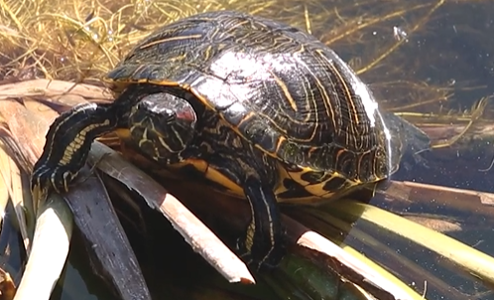 |  | https://arizona.box.com/s/mv4bsau0ctddtu0p6t8mbaouj7d0ceuv
Organism 2 | 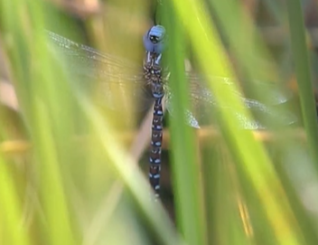 | https://arizona.box.com/s/y8ghnxfkvothkjrtzfcml9p0be95hhw6
Organism 3 | 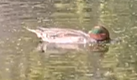 | https://arizona.box.com/s/tctnxfgelacjmilpvtgjwok91abaccle
Organism 4 | 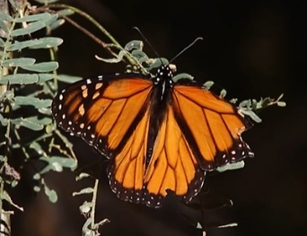 | https://arizona.box.com/s/9lytk7sc43olrymi7g4qn1ldw1bd80sr
Organism 5 | 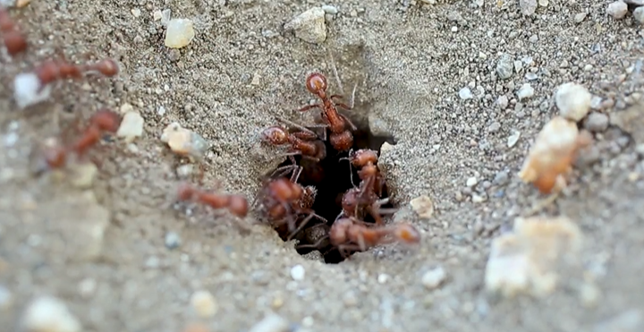 | https://arizona.box.com/s/8nxyyi17ncwdmp3kv2d6egxqpkiazgh5
Organism 6 | 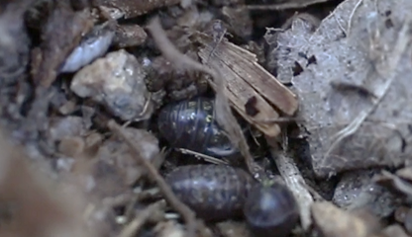 | https://arizona.box.com/s/wogxdorjgqf9ensubds3gxrfm6csxajx

