**Soil Texture Triangle**

Conduct jar test: Dig a hole at least 1 foot deep. Fill a large, clear jar half full of soil and half with water. Shake sample in jar, allow soil to settle out.

The next day use a ruler to measure the height of the soil in the jar and the thickness of each layer. The heavier earth materials should be closer to the bottom. Then you can figure out what percentage each layer is of the entire thickness of soil. In other words, if the sand is 3 centimeters thick out of a total of 10 centimeters of soil, then our percent sand is 30%. Use the Soil Texture Triangle (below) to figure out what kind of soil you have.

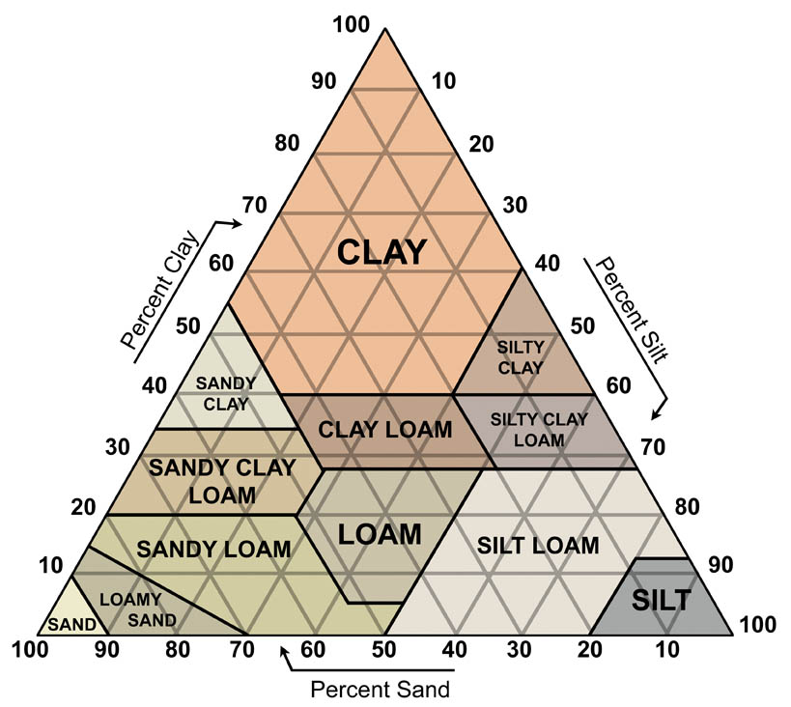

Based upon the results of the jar test for your site, ask the students how fast or slow they think the water will enter the ground? Use the Texture and Permeability Table (below) to figure out how fast water will move through the soil. You can see that sandier or more gravelly soils will allow water to infiltrate faster. Silt and clay inhibit the flow of water into the ground.

|  |  |  |
| --- | --- | --- |
| **Texture** | **Permeability** | **Estimated Perc Rate Value** |
| Sand, loamy sand | Rapid and very rapid (>6.0 in/hr) | Fast |
| Sandy loam | Moderately rapid (2.0 - 6.0 in/hr) | High Average |
| Loam, silt loam | Moderate (0.6 - 2.0 in/hr) | Average |
| Sandy clay loam | Moderately slow (0.2 - 0.6 in/hr) | Slow |
| Clay loam, silty clay loam | Moderately slow (0.2 - 0.6 in/hr) | Slow |

*From Soils Interpretation Help Sheet, Soils CDE – Interpretation Sheet (November 2010)*